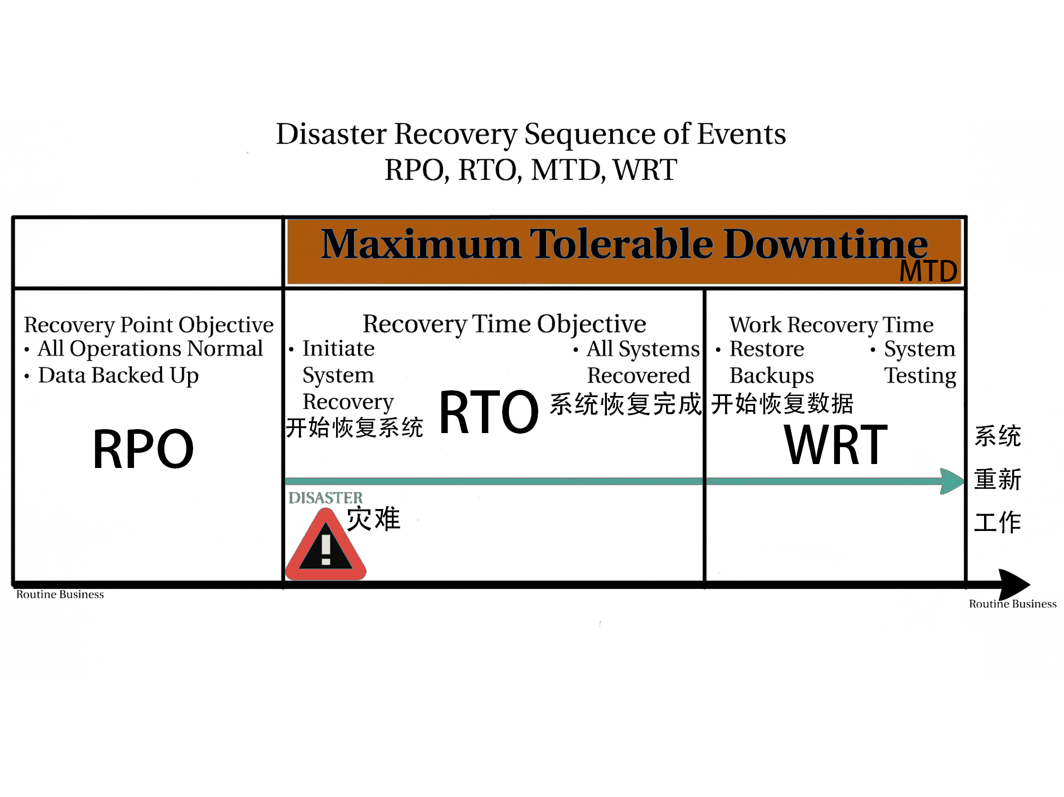

**Maximum tolerable downtime (MTD) 可容忍的最大停机时间**

Definition:

Outage time that can be tolerated by the company as a result of various unfortunate events

由于各种不幸的事件，公司可以容忍的停工时间

The BIA identifies which of the company’s critical systems are needed for survival and estimates the outage time that can be tolerated by the company as a result of various unfortunate events.

The outage time that can be endured by a company is referred to as the maximum tolerable downtime (MTD) or maximum period time of disruption (MPTD)

BIA确定了公司的哪些关键系统是需要生存的，并估计了公司因各种不幸事件而可以容忍的停工时间。公司可以忍受的停工时间被称为最大可容忍的停工时间（MTD）或最大中断时间（MPTD）

The following are some MTD estimates that an organization may use. Note that these are sample estimates that will vary from organization to organization and from business unit to business unit:

以下是一个组织可以使用的一些MTD估算。请注意，这些是样本估计，在不同的组织和不同的业务单位会有所不同。

* **Nonessential 非必要的** 30 days
* **Normal 通常** 7 days
* **Important 重要的** 72 hours
* **Urgent 紧急的** 24 hours
* **Critical 关键的** Minutes to hours

Each business function and asset should be placed in one of these categories, depending upon how long the company can survive without it. These estimates will help the company determine what backup solutions are necessary to ensure the availability of these resources. The shorter the MTD, the higher priority of recovery for the function in question. Thus, the items classified as Urgent should be addressed before those classified as Normal.

每项业务功能和资产都应该被归入其中一个类别，这取决于公司在没有它的情况下可以生存多久。这些估计将帮助公司确定哪些备份解决方案是必要的，以确保这些资源的可用性。MTD越短，有关功能恢复的优先级就越高。因此，归类为紧急的项目应该在归类为正常的项目之前解决。

**The recovery point objective (RPO) 恢复点的目标**

Definition:

Determined based on the acceptable data loss in case of disruption of operations. It indicates the earliest point in time to which it is acceptable to recover the data.

根据业务中断情况下可接受的数据损失来确定。它表明可以接受恢复数据的最早时间点。

The Recovery Point Objective (RPO) is the acceptable amount of data loss measured in time. This value represents the earliest point in time at which data must be recovered. The higher the value of data, the more funds or other resources that can be put into place to ensure a smaller amount of data is lost in the event of a disaster.

恢复点目标（RPO）是以时间衡量的可接受的数据损失量。这个值代表了数据必须被恢复的最早时间点。数据的价值越高，可以投入更多的资金或其他资源，以确保在灾难发生时损失较少的数据。

**The recovery time objective (RTO) 恢复时间的目标**

Definition:

Determined based on the acceptable downtime in case of a disruption of operations. It indicates the earliest point in time at which the business operations must resume after a disaster.

根据业务中断时可接受的停机时间来确定。它表明灾难发生后，业务运作必须恢复的最早时间点。

**Work Recovery Time 工作恢复时间**

Definition:

The Work Recovery Time (WRT) is the remainder of the overall MTD value. RTO usually deals with getting the infrastructure and systems back up and running, and WRT deals with restoring data, testing processes, and then making everything “live” for production purposes.

工作恢复时间（WRT）是整个MTD值的剩余部分。RTO通常是指让基础设施和系统恢复运行，而WRT是指恢复数据、测试流程，然后让一切 "活 "起来用于生产。

—-------------------------------------------------------------------------------------------------------------------------------------

Both RPO and RTO are based on time parameters. **The lower the time requirements, the higher the cost of recovery strategies.**

RPO和RTO都是基于时间参数的。**时间要求越低，恢复策略的成本就越高。**

* If the RPO is in minutes (lowest possible acceptable data loss) then data mirroring should be implemented as the recovery strategy.

如果RPO是以分钟为单位（可接受的最低数据损失），那么应该实施数据镜像作为恢复策略。

* If the RTO is less, then the alternate site might be preferred over a hot-site contract.

如果RTO较少，那么备用站点可能比热站点合同更受欢迎。

* The lower the RTO, the lower the disaster tolerance. Disaster tolerance is a time gap within which the business can accept the non-availability of IT facilities.

RTO越低，灾难容忍度越低。灾难容忍度是一个时间差，在这个时间差内，企业可以接受IT设施的不可用性。

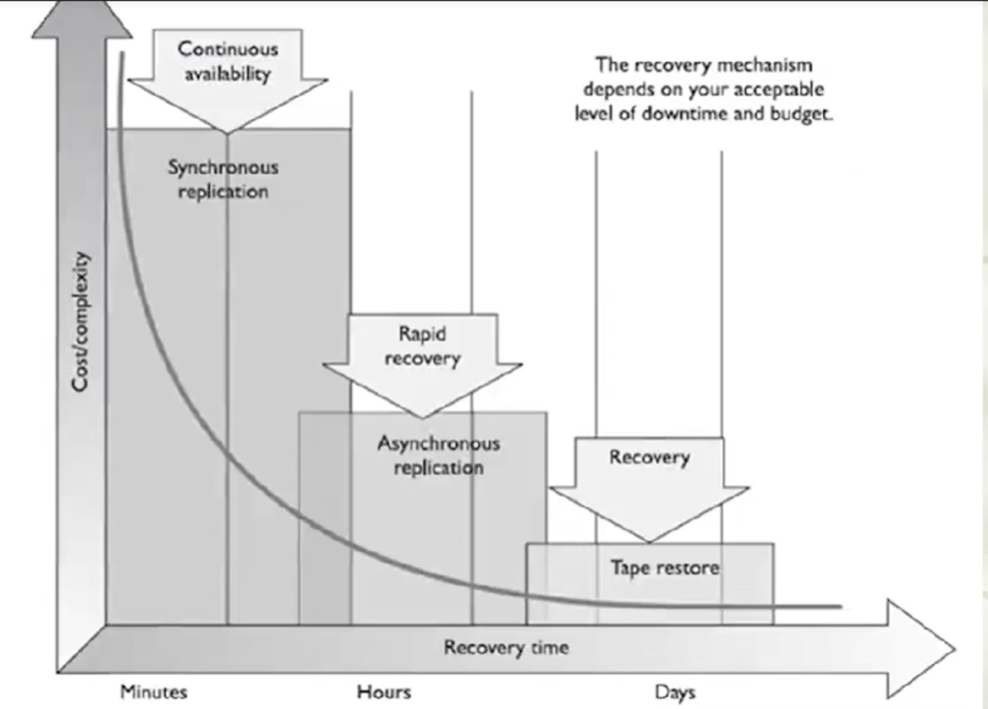

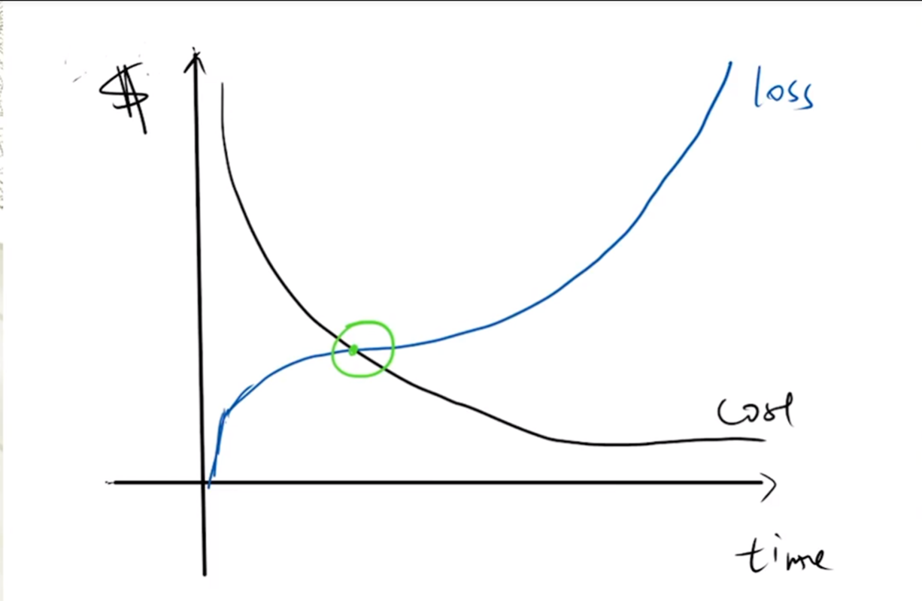

Cost of recovering is more than the cost of loss with every unit of time that passes before the Optimum time. The method may not be worth its price.

在最佳时间之前，每过一个单位的时间，恢复的成本就会超过损失的成本。该方法可能不值得它的价格。

Cost of loss is more than the cost of recovery with every unit of time that passes after the Optimum time. Loss due to damage is too high.

在最佳时间之后，每过一个单位的时间，损失的成本就会超过恢复的成本。损害造成的损失太高。